cOurse planner

System Requirement Specification Document

Girish Srinivas

gsrinivas@unomaha.edu

Table of Contents

Introduction 3

Purpose of the system 3

Scope of the system 3

Objectives and Success criteria of the project 3

Definitions and Abbreviations 4

Overview 4

System Context 4

Usage facets 4

Requirement sources 4

Context Objects 5

Properties and Relationships 5

Subject Facets 5

Requirement Sources 5

Context objects 6

Properties and Relationships 6

Proposed System 6

Goal Model 7

Strategic Rationale Model 7

Goals 7

Functional Requirements 8

Student 8

Advisor 8

Non-functional Requirements 9

Scenarios 9

Student 9

Advisors 11

Data model 14

Dynamic model 14

Use case Diagram 14

Sequence diagram 15

State chart diagram 15

Screen mockups 16

Screenshots and User Acceptance cases 23

Summary 30

# Introduction

In present day scenario, maintaining a plan of study has become a tedious task for both the students and advisors since it leads to redundancy, confusion and inconsistency, because the existing system uses trivial methods (like the use of spread sheets) to maintain the study plan.

In order to avoid this redundancy, a system has been proposed as a solution which effectively manages all the inconsistencies of the current system.

## Purpose of the system

The purpose of the system is to reduce redundancy in generating course plans for students and provide hazel free operation. The system provides various features like maintaining a course plan (tentative plan of study), enrolment / dropping of a course, CGPA calculator, Degree works and generates unofficial transcripts etc. which will help students to keep track of their progress.

Since the system is completely online, the student / advisor can interact with the system fulfil their tasks.

## Scope of the system

This system comes into action when the student is admitted to the university and issued an I-20 form. An account will be created for the student to access services provided by the university. The Graduate advisor then adds the student to the system once admit status is confirmed, an initial plan of study with possible pre-requisite courses is created by the advisor and sent to the student. The student logs into the system by using the credentials generated by the university and can look up his initial plan of study. If the student wishes to have a change in the initial plan of study, may do so by updating the course plan based on his preference and available courses for the current semester and notify the changes to the advisor. The advisor then reviews the modified course plan and may advice possible changes or approve the course plan and notifies the student for enrolment.

At the end of the term, the grades for enrolled courses are updated in the course plan and the unofficial transcripts are generated. The degree works shows the progress of the student towards completion of degree by showing the completed courses, enrolled courses for the upcoming semester along with total credit hours remaining based on the exit requirements chosen by the student.

For the system to be deployed, it has to have access to user information from university database. The system operates only within the restricted environment of particular disciplines offered by the university. And this system performs specific operations restricted to their respective disciplines.

## Objectives and Success criteria of the project

The objective of the Course Planner is to maintain a course plan for each student as a tentative plan of study using which he can enroll for courses. This eliminates the redundancy of maintaining multiple course plans by the student and the advisor whenever there is a change in the course plan.

The system also helps in maintaining of the plan of study for the students, where in the student as well as the advisors can modify the course plan and have the latest one available at all time which helps the advisor to better advice students and keep track of student’s progress towards their completion of degree.

## Definitions and Abbreviations

|  |  |
| --- | --- |
| **Terms** | **Descriptions** |
| Student | Stakeholder of the system |
| Advisor | Stakeholder of the system |
| Course Plan | Program of study which includes the student’s concentrations, and courses which he can enroll. |
| Degree works | Shows the progress of student towards completion of degree |
| CGPA / GPA | Cumulative Grade Point Average |
| Pre-requisites Courses | Foundation courses required to be completed by the student, if he does not meet the requirements for the program. |

## Overview

The system is designed as a web based application which supports the following tasks:

* It can be used to maintain a tentative plan of study created by the advisor for the students.
* Using this the student can decide whether to enroll for a course or to withdraw it any time before the actual enrollment happens.
* Using this system, one can easily track their progress towards completion of degree
* The system generates CGPA for the courses enrolled and finished by the student.
* This system allows a student to drop any ongoing course.
* This system also generates unofficial transcripts.

# System Context

## Usage facets

### Requirement sources

* *Direct Users*: The direct users for the online course planner are students who are admitted to the university and the advisors.
* *Indirect Users:* The indirect users for the online course planner is the administrator who will be creating new users for the system and maintaining the system.
* *Existing System:* The existing system for the course planner consists of multiple systems which does different tasks, one for registration of course and course progress and another system for designing the course plan for th1e students. But, there is no unified system which integrates all the tasks into one system.

### Context Objects

* *User Groups:* The user groups for online course planner are Students and Advisor.
* *Input modality of user interface:* The user has to enter nuid and password to login to their account. The user should have a valid email address. Upon changing the password for their account, a notification mail has to be sent. Upon receiving any notification, an email has to be sent to the user.
* *Usage workflow:*
  + Review course plan
  + Add courses to the course plan
  + Seek approval from advisor
  + Register for courses
  + Track term progress
  + Calculate the course credit hours to be finished
  + Track graduation requirement progress

### Properties and Relationships

* The advisor should be able to view all the student who are currently enrolled
* The advisor should be able to edit course schedule
* The student should be able to edit course plan by adding or removing courses
* The student should be able to registers for courses added to the course plan
* The student or advisor should be able to view the academic progress

Subject Facets

### Requirement Sources

* Domain Experts: System architect
* Stakeholders: Students, Advisor
* Rules of the system:
* A graduate full time student should enroll for 9 credit hours or more.
* A graduate part time student should enroll for at least 3 credit hours or more.
* An international student is always enrolled as a full time student.
* Local students can be part time students if and only if they are employed as full time employees.
* All grades are assigned based on University’s grading policies.
* For a Master’s student to graduate a minimum of CGPA of grade B (3.0) is required.
* Total credit hours required for a Computer Science Master’s student to complete graduation based on his exit requirements are:
* Capstone: 33 credit hours
* Project / Thesis: 30 credit hours
* If a full time student is employed as an intern for 3 credit hours, then he can waive a course of 3 credit hours.
* A student can get a minimum grade of one B- in the core courses.
* A student should get a minimum grade of B in the pre-requisites courses.
* *Existing system:*
  + Mavlink is the existing system which is used for enrolment of courses, display grades and to calculate progress towards graduations.
  + But this system does not have functionality to store the course plan for student to access and update.
  + The advisor uses Microsoft Excel to store each student’s course plan.

### Context objects

* *Persons whose data is stored:*  Students and advisor
* *Immaterial Objects:*User’s data from the university like “nuid”, “netid”, “concentration” and “pre-requisite courses” for students along with their personal details.
* *Process:*The system should be provided with user information from the university to access and assign logins for each student and advisor.
* The advisor will assign logins for new students and keep track of existing students in the program.
* The students will access the system for updating their course plan and for enrolment of courses.
* The advisor will be able to update course schedule and keep track of each student’s progress towards graduation.

### Properties and Relationships

* Relevant properties of the identified context objects are:
  + Each user (student / advisor) will have “netid”, “nuid” and their personal information.
  + Each student is assigned an advisor
  + Each student has a concentration and may have set of pre-requisite courses

# Proposed System

The system is designed as a web application which is capable of performing functionalities which are not supported by the currently existing system. The web interface is designed to provide a smooth interaction with the system.

The proposed system has the following functionalities:

* The system can maintain a tentative plan of study (course plan) for each student.
* The student can modify the course plan based on the availability of courses.
* The student can enroll / drop any course based on the tentative plan of study.
* The Student can also keep track of progress towards completion of degree based on the remaining credit hours and his CGPA.
* The advisor can modify the course plan according to the concentration chosen by the student.
* The advisor can update the grades for the completed courses in the course plan, to keep the student updated.
* The system can generate reports for each student.

# Goal Model

## Strategic Rationale Model

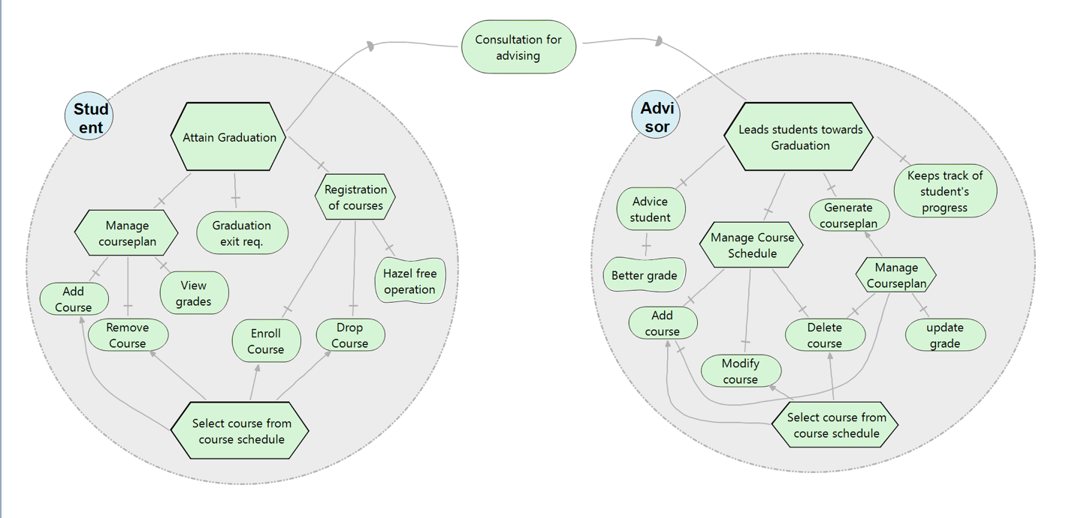

## Goals

* Stakeholders:
  + Student
  + Advisor
* *Student*: The major task of the student is to graduate from the program. The other tasks associated with this involves registration of courses with goals being enrollment of a course and dropping of course with hazel free operation. The task managing course plan (Plan of study) involves adding / removing the course from the course plan which allows the student to view his / her grades on successful completion of the course at the end of the semester, which decides the standings of the student (Good standings or probation). For a student to graduate successfully from the program he / she need to keep track of No. of credits completed using the Grad exit requirement.
* *Advisor*: the major task of the advisor is to lead the students towards graduation. The goals associated with the task is to advise students, generate course plan for the student and keeps track of student’s progress. Due to good advising a soft goal of a student getting better grade is achieved. The other tasks of the advisor involve managing the course schedule which involves adding / removing / updating the course schedule which allows the students to enroll for the courses for the semester and to manage the course plan of the student (plan of study). The advisor also updates the student’s course plan with grades obtained for that course at the end of the semester which helps him / her to keep track of student’s progress and lead them to graduate from program.

# Functional Requirements

## Student

1. As a student, in order to view my profile, I want to login
2. As a student, in order to enroll for new courses, I want to add the course to the course plan
3. As a student, in order to enroll for the current semester, I want to enroll for course.
4. As a student, in order to delete a course from the course plan, I want to remove the course from course plan.
5. As a student, in order to audit the course for current semester, I want to drop course.
6. As a student, in order to check my results, I want to view my grades.
7. As a student, in order to plan my course work, I want to view the course information.
8. As a student, in order to plan my course work, I want to manage my course plan.
9. As a student, in order to notify the advisor regarding change in the course plan, I want to email the course plan to my advisor.
10. As a student, in order to manage my course plan, I want to calculate the number of credits required based on the exit plan for graduation (Thesis, Capstone or Project).
11. As a student, in order to view my course progress, I want to generate a progress report.
12. As a student, in order to end the session, I want to logout.

## Advisor

1. As an advisor, in order to view the homepage, I want to login.
2. As an advisor, in order to view all the students admitted to the university, I want to view all students.
3. As an advisor, in order to view students who are currently enrolled, I want to view currently enrolled students.
4. As an advisor, in order to access student’s academic information, I want to view student’s information.
5. As an advisor, in order to approve the courses for registration for the students, I want to approve courses for enrollment.
6. As an advisor, in order to update the course schedule for every semester, I want to edit course information.
7. As an advisor, in order to keep track of a student’s course work, I want to generate a course plan for students.
8. As an advisor, in order to view the course plan for a particular student, I want to view the course plan of a given student
9. As an advisor, in order to make changes to the existing course plan, I want to edit the course plan of a given student.
10. As an advisor, in order to notify student on modification of course plan, I want to email the course plan to the student.
11. As an advisor, in order to keep track of student’s progress, I want to view student’s progress towards graduation.
12. As an advisor, in order to view or update a student’s grade if there is a change, I want to manage students grades on approval of the respective professor of the course.
13. As an advisor, in order to end the session, I want to logout.

# Non-functional Requirements

• Usability: The software is designed for a website to make it as usable as possible. The website is also made up of a series of simple buttons to keep it simple and easy to understand by users with different levels of experience

• Reliability: The prototype of the application has been developed. The probability of failure-free software operation on a designed test suite proved reliable. The software reliability will be mainly determined by how reactive the website is to user input. Edge-case errors when posting data could be a major source of software reliability problems. This could be determined by the database structure and the queries to the database upon the post request.

• Performance: The software is designed in such a way that the use of sophisticated api’s guarantee optimal performance at any given time. The software is flexible enough to add new modules which increases its functionality. The performance of the software depends on the type of the database suite used and the load on the software because certain database suites does not perform synchronous read/write operations when subjected to a maximum load.

• Supportability: it’s a cost effective product, easily scalable and can be maintained easily.

• Interface: The system uses a web interface which is easy to navigate by the user which is visually appealing.

• Legal: Personal information of the user is secured. The product will provide intellectual property rights.

# Scenarios

Feature: Course planner system

As a new student of the university, I want to enroll for the courses based on the courses available for that particular semester

As an advisor, I want to update the information regarding courses as well as specific student’s course plan information and also to view student’s progress towards graduation.

## Student

1. Scenario: Student login.

When I choose the student login option.

And I login using my credentials provided by the university

Then I will be directed to my homepage which will prompt me to change my password.

1. Scenario: Adding the course into the course plan

When I login to my home page using my login credentials,

And I choose view course schedule

And I choose the term of semester

Then I will be directed to the page which displays the available courses for that particular semester.

And when I choose the option add-course

Then that course should be added on to my course plan as one of the subject

Based on the previous courses enrolled and completed, the system should not allow adding more than two six ending courses, and also adding internship for more than 3 credits is not allowed

When I try to add Capstone / Thesis / Project as the exit requirement to the course plan,

Then the system should add the exit requirements to the course plan only if I have successfully completed required core courses (with grade better than B or above).

1. Scenario: Enrolling for the course

When I login to my home page using my login credentials,

And I choose view course plan option

And I receive approval from the advisor

And I choose enroll option

Then the system should register my courses.

When I try to register for other courses

And I choose register option

Then the system should register the courses which are newly added

1. Scenario: Removing the course from the course plan

When I login to my home page using my login credentials,

And I choose the option view course plan

And I choose the option remove course from the current semester.

Then that course should be removed from my course plan

When I try to remove a course from the previous semester

Then I get a message warning me that I cannot perform this action.

When I try to remove a course from the current semester after registering for the courses

Then I get a message warning me that I cannot perform this action.

1. Scenario: Dropping a course

Given: I have already registered for courses.

When I login to my home page using my login credentials,

And I choose view course plan option

And I choose drop course option

Then the system should allow me to choose a course to be dropped

And I choose the drop option next to the course

Then the course should be removed from my course plan.

1. Scenario: View Grades.

When I login to my home page using my login credentials,

And I choose course plan option.

Then I will be able to view my grades for the courses which are completed.

1. Scenario: View Course Information.

When I login to my home page using my login credentials,

And I choose Course schedule option.

Then I will be able to view the complete course offered for the next semester along with other details regarding the course and the instructors who are offering the course.

1. Scenario: View course plan.

When I login to my home page using my login credentials,

And I choose course plan option.

Then I will be directed to my course plan page which displays the plan layout designed by the advisor for each semester, which includes number of credit hours to be taken for each semester and also based on the criteria for selecting a course based on concentration.

1. Scenario: Notifying the course plan to the advisor

When I login to my home page using my login credentials,

And I choose view course plan option

And I choose email course plan to advisor

Then I will be provided with options to choose to which of the advisor’s to send to.

And when I choose send option

Then the system should email the course plan to the selected advisor

1. Scenario: Graduate exit requirements

When I login to my home page using my login credentials,

And I choose Exit requirements

And I choose the Exit requirements as one of the options (Thesis, Capstone or Project)

Then the system should display the information about the course credit hours take, with the remaining credit hours to be completed in a tabular form. It should also display the progress using a progress bar with appropriate value in percentage form.

1. Scenario: Generate reports for graduation

Given: I have already registered for courses.

When I login to my home page using my login credentials,

And I choose reports option

Then the system should be able to display my grades for each semester course wise and also display the calculate CGPA.

1. Scenario: Logging out.

When I choose the logout option.

Then, session for that student should be deleted and should be redirected to the logged out page which displays an appropriate message.

## 

## Advisors

1. Scenario: View home page.

And I choose login option

And When I login to my home page using my login credentials,

Then display home page

1. Scenario: View students

Given: students are admitted to university

When I login to my home page using my login credentials,

And I choose an option student’s info

And I choose an option form a dropdown list for all students

Then, display a list of are students who are yet to graduate.

1. Scenario: View currently enrolled students

Given: Students register for the courses

When I login to my home page using my login credentials,

And I choose the option student’s info

And I choose an option from the dropdown list for currently enrolled students.

Then the system displays all the students who are enrolled currently for the semester.

1. Scenario: View a student’s information

When I login to my home page using my login credentials,

And I choose the option search student

Then the system opens a page where it prompts for NUID to be entered

Then after entering the NUID, the system displays the student’s record which includes his grades for all the courses.

1. Scenario: Approving the courses for registration

When I login to my home page using my login credentials,

And I choose the notification of a particular student from the notification list

And that student’s course plan is displayed

And next to the courses for current semester choose approve or disapprove option

And choose send option

Then the system notifies the student about the courses in the course plan

1. Scenario: Edit course information

When I login to my home page using my login credentials,

And I choose the option edit course information

Then the system displays a popup to add a new course or update existing course information or remove course.

When I choose add new course option

Then a form is displayed where the information about the new course are added

When I choose update option

Then a form with dropdown is displayed where the form is filled with the dropdown for the course and the section number is displayed and the respective fields are updated accordingly.

When I choose the remove option

Then a form is displayed which prompts the advisor to enter the course number and section number to be deleted.

1. Scenario: Generate a course plan

When I login to my home page using my login credentials,

And I choose the option Add student,

Then the system opens a page which prompts for creation of course plan which will create a course plan and lets me add pre-requisites if they are required by the student.

1. Scenario: To view course plan

When I login to my home page using my login credentials,

And I choose the option search student

Then the system opens a page where it prompts for NUID to be entered

Then after entering the NUID, the system displays the student’s info

And I choose course plan option

Then he system displays the course plan for that student.

1. Scenario: To update course plan

When I login to my home page using my login credentials,

And I choose the option search student

Then the system opens a page where it prompts for NUID to be entered

Then after entering the NUID, the system displays the student’s info

And I choose course plan option

Then he system displays the course plan for that student

And I choose edit option

Then the system allows the advisor to add/remove courses to the course plan

1. Scenario: Notification from students about course plan

When I login to my home page using my login credentials,

And I choose notification option from the home page

Then a dropdown list is generated, showing all the notifications from the students.

And I choose a student’s notification

Then the system should display that student’s information page for course plan.

1. Scenario: To view student’s progress towards graduation

When I login to my home page using my login credentials,

And I choose the option search student

Then the system opens a page where it prompts for NUID to be entered to display student’s info

And I choose degree works option

Then the system displays a page which show the student’s progress towards his / her degree completion in the form of progress bar and along with an unofficial transcript of grades for each course completed.

1. Scenario: Update student’s grade

When I login to my home page using my login credentials,

And I choose the option search student

Then the system opens a page where it prompts for NUID to be entered to display student’s info

And I choose update grades form the student’s info page.

Then the system prompts to enter a new grade.

1. Scenario: Logging out.

When I choose the logout option.

Then, session for that advisor should be deleted and should be redirected to the logged out page which displays an appropriate message.

# Data model



# Dynamic model

## Use case Diagram

# ../Downloads/UseCase.jpg

# Sequence diagram

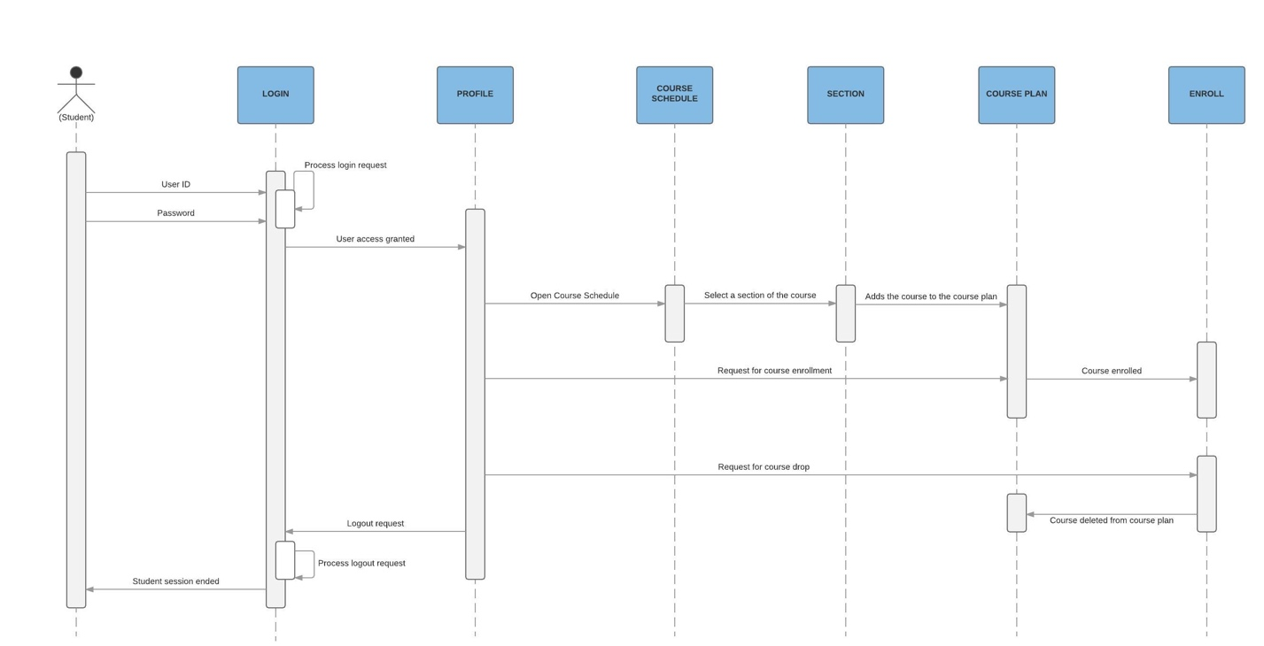

## State chart diagram

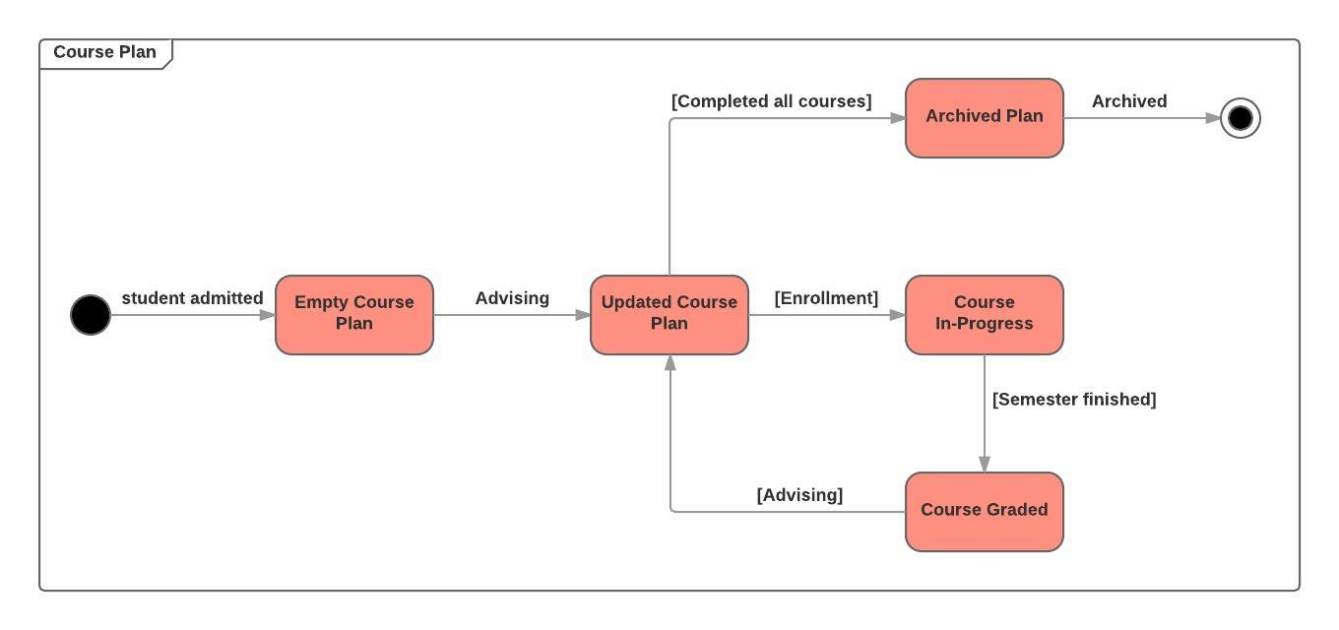

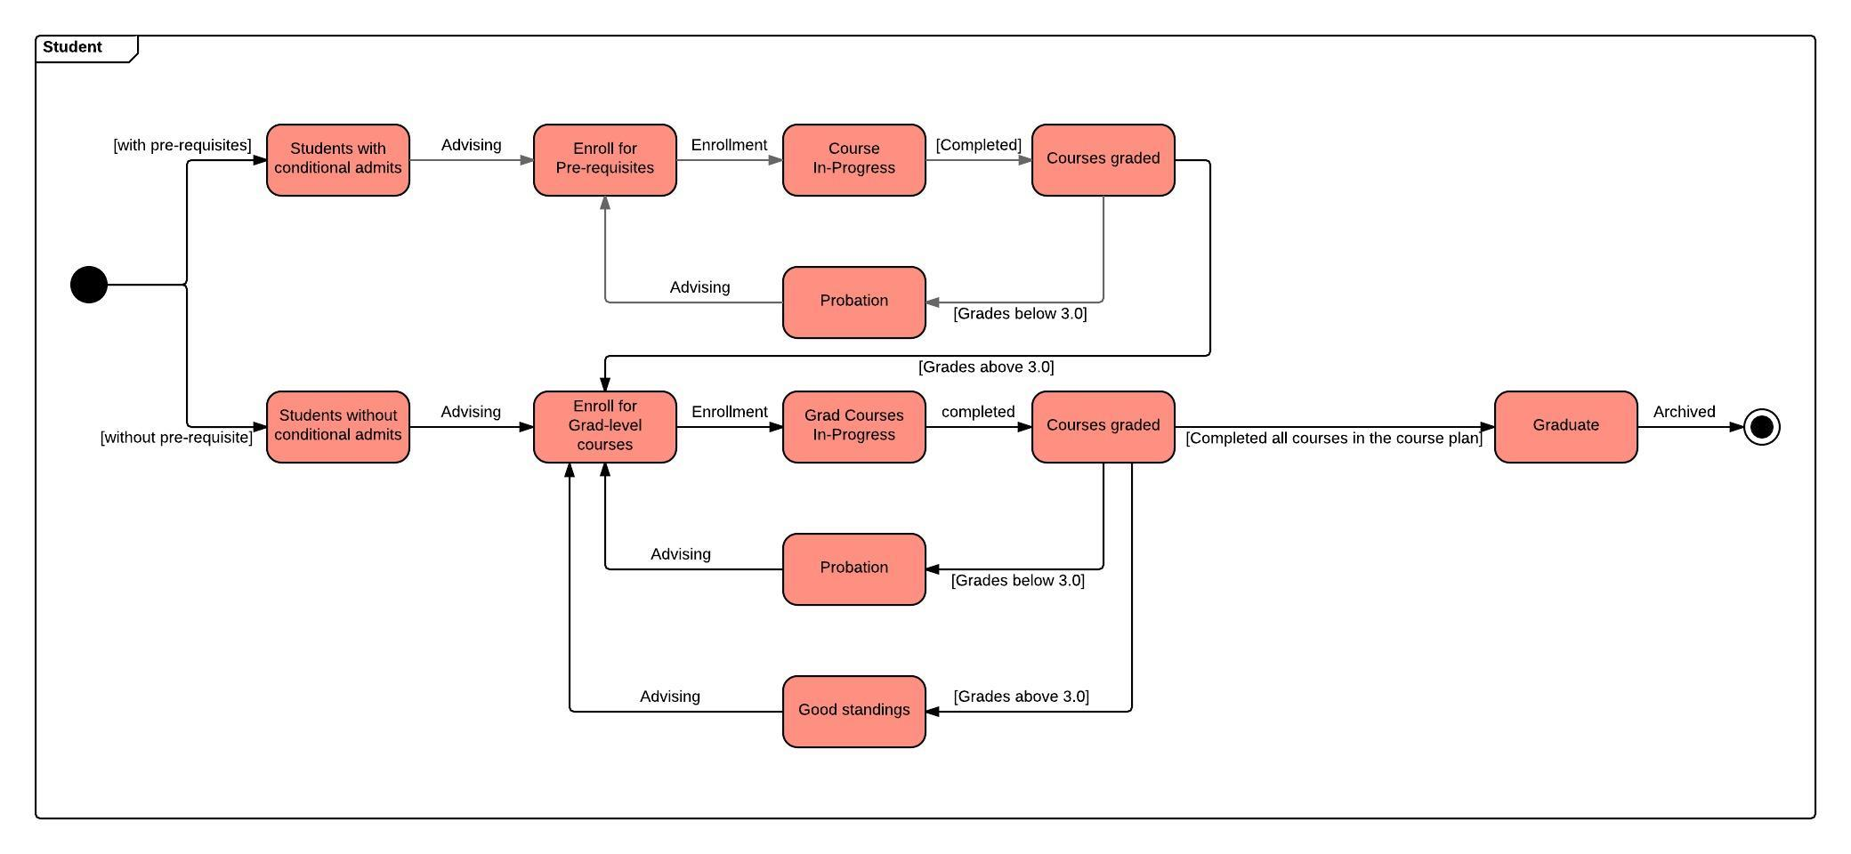

# 

# Screen mockups

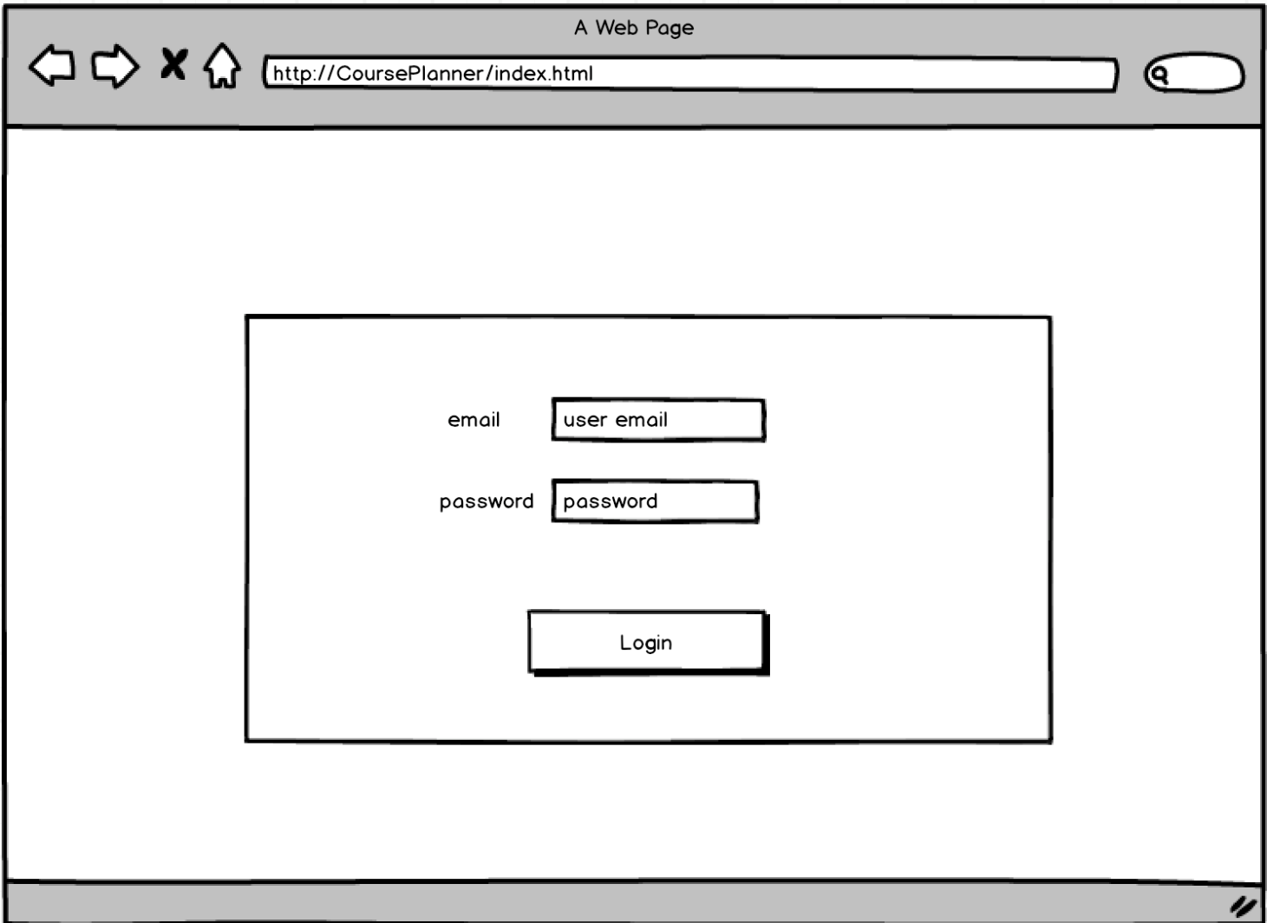

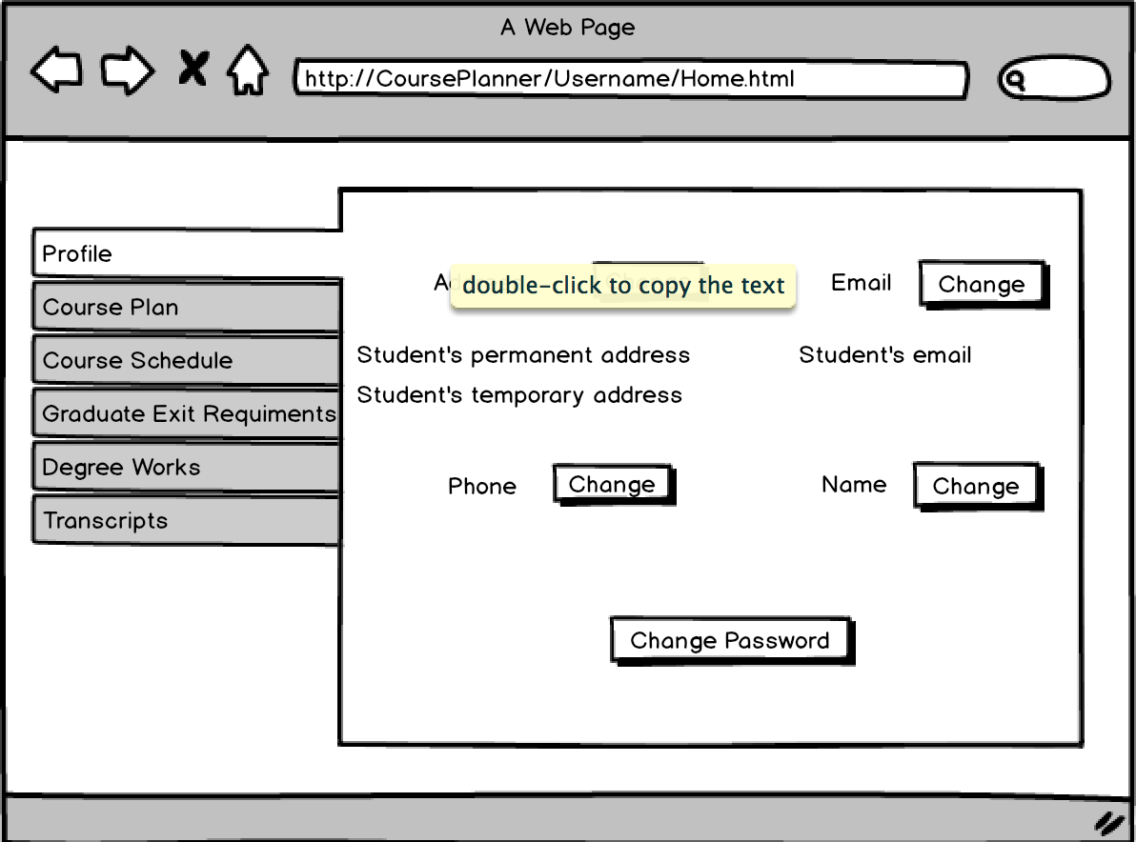

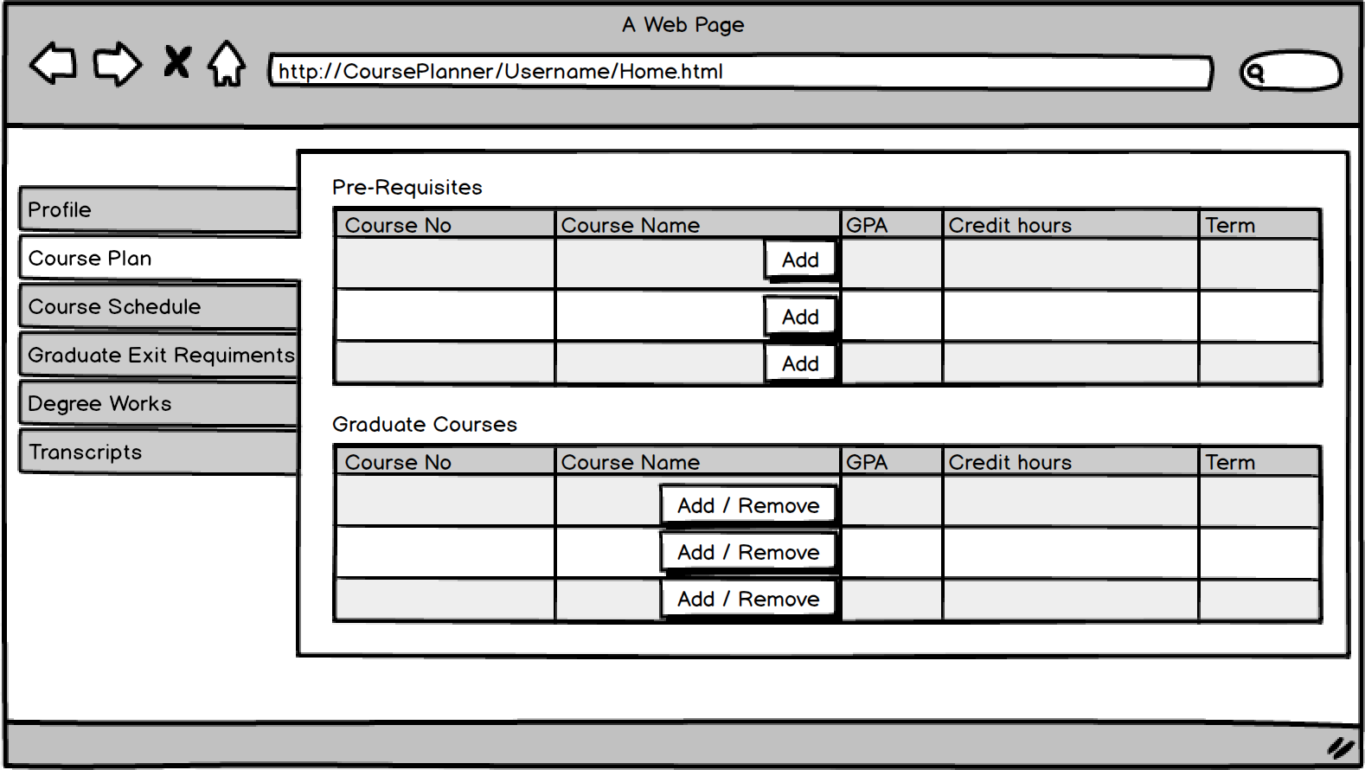

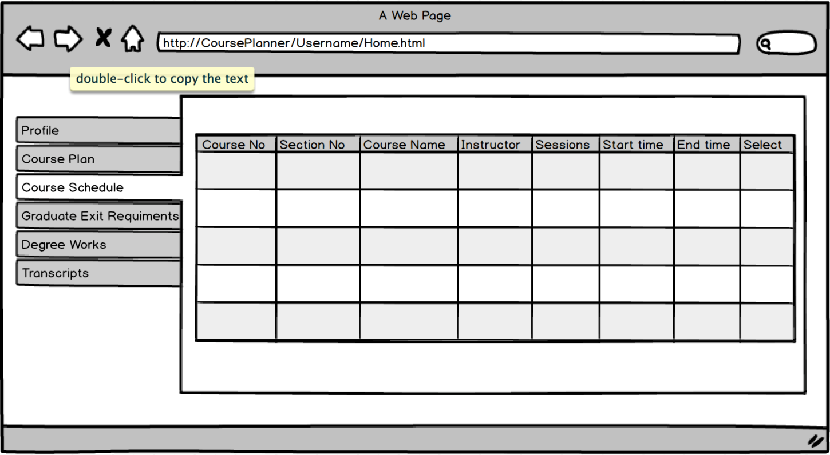

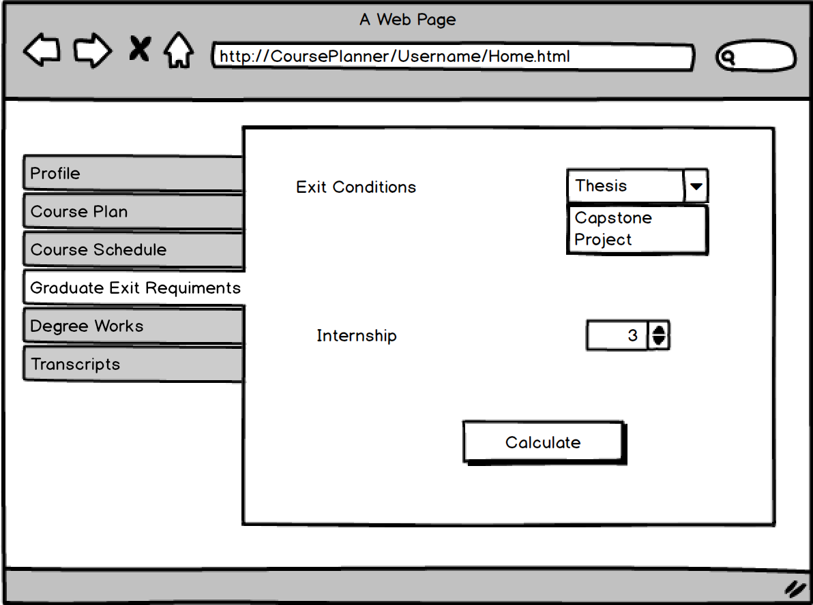

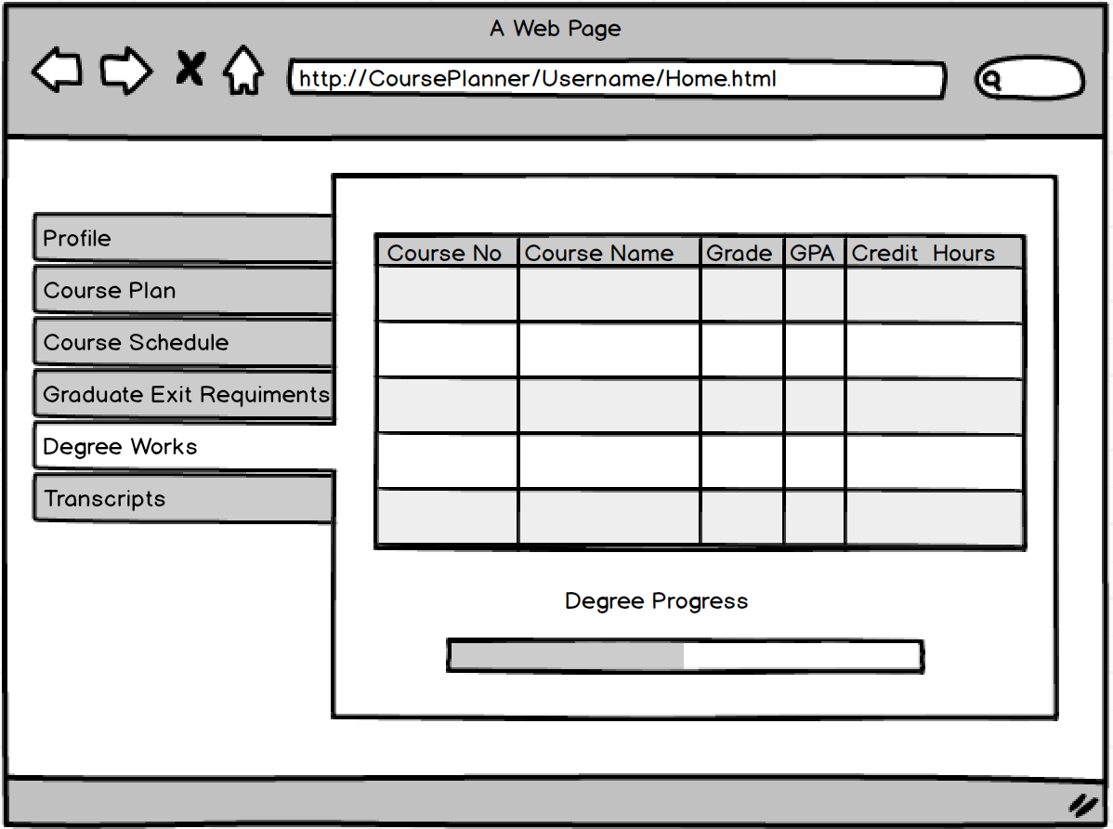

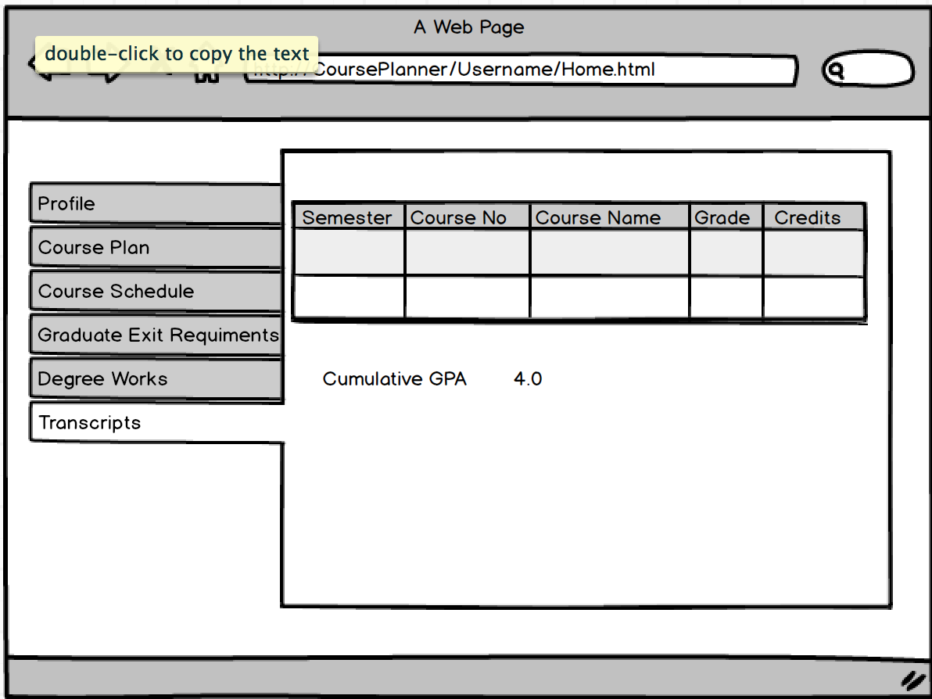

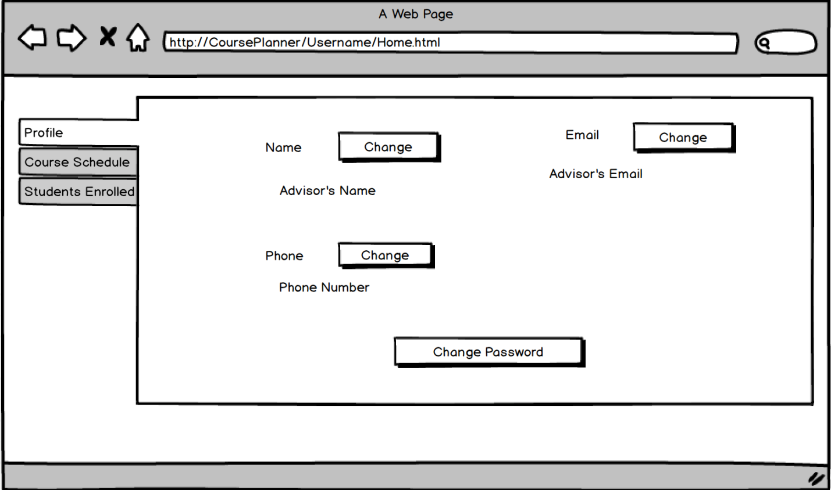

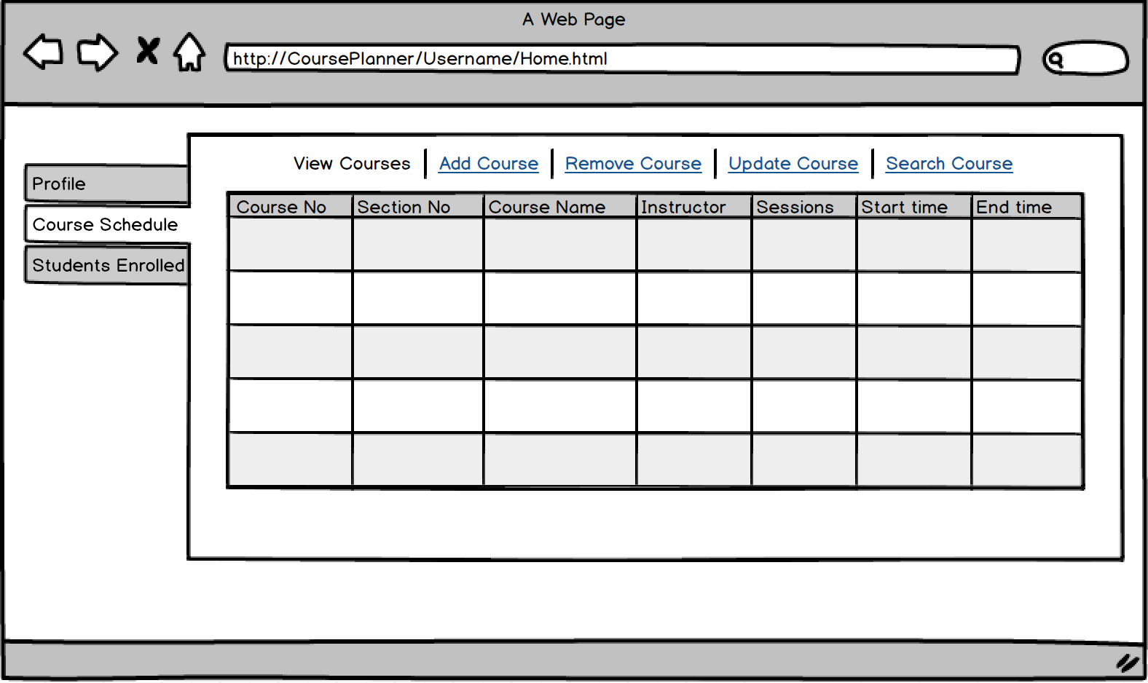

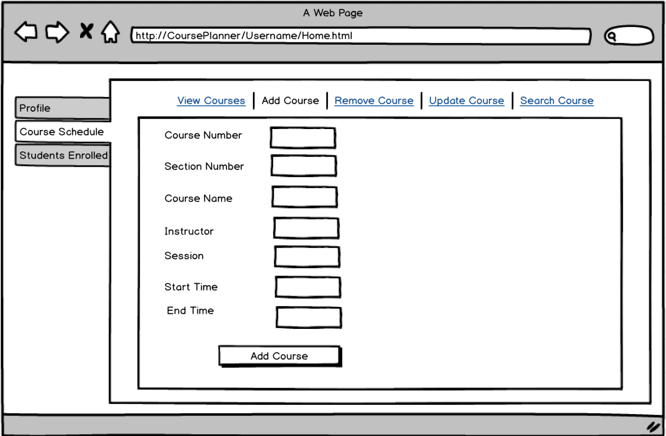

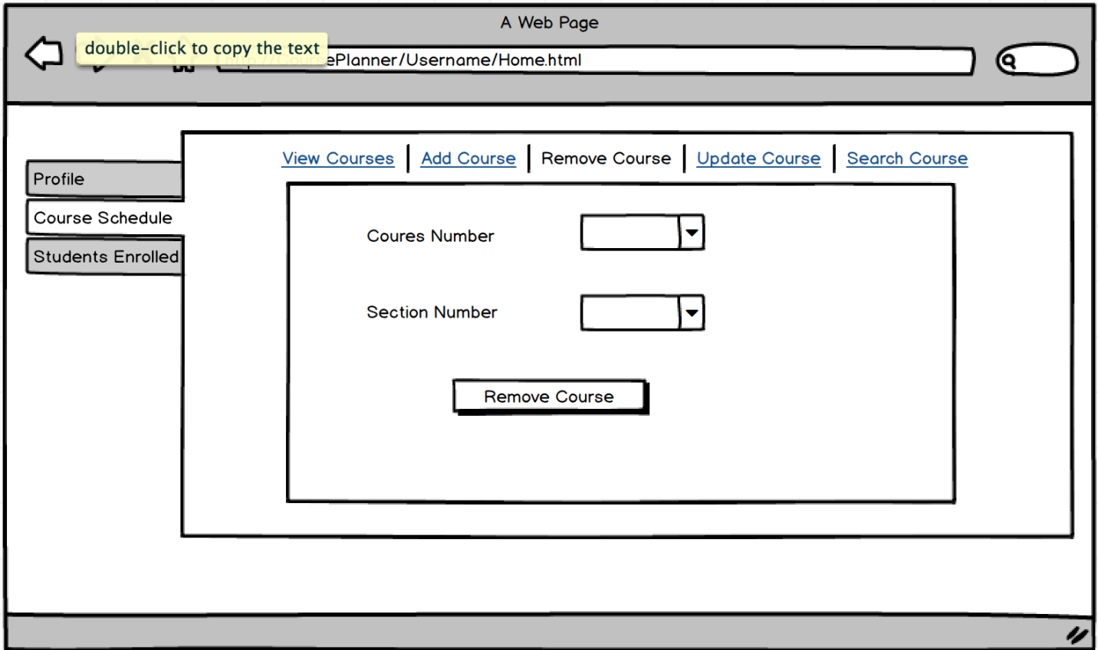

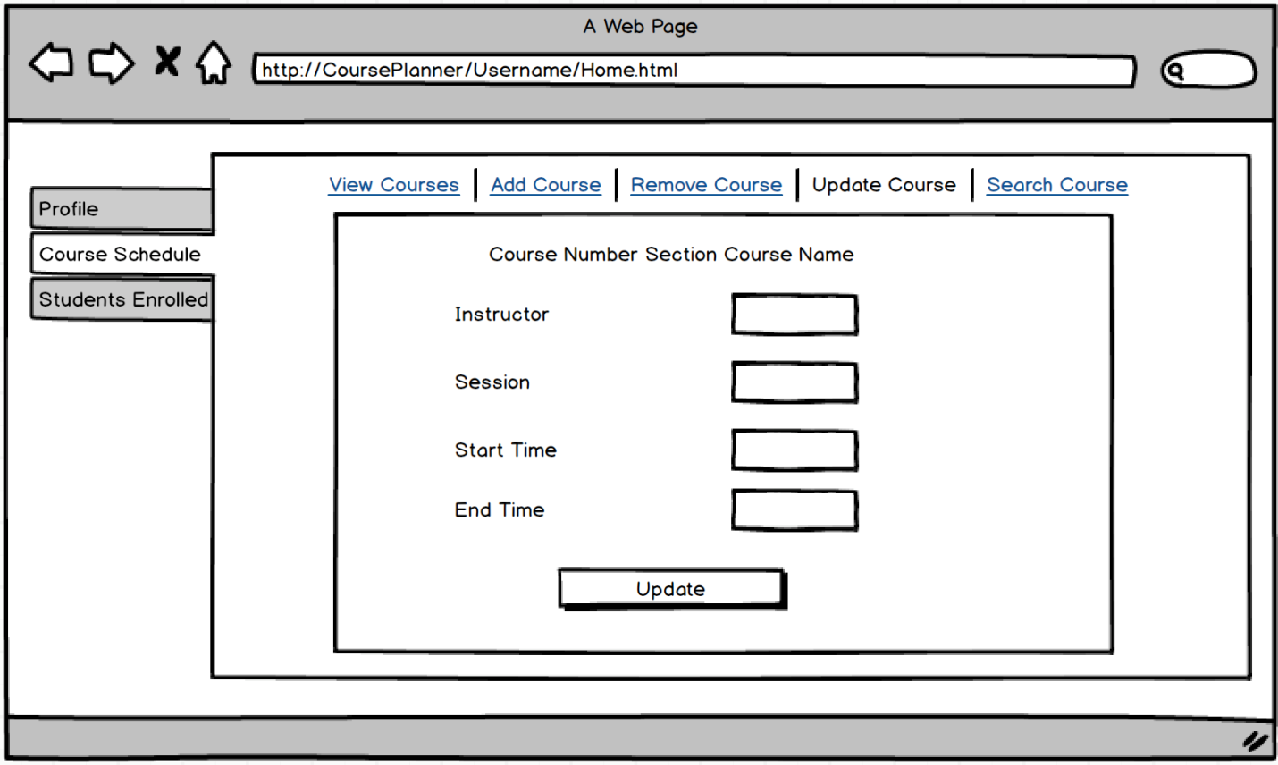

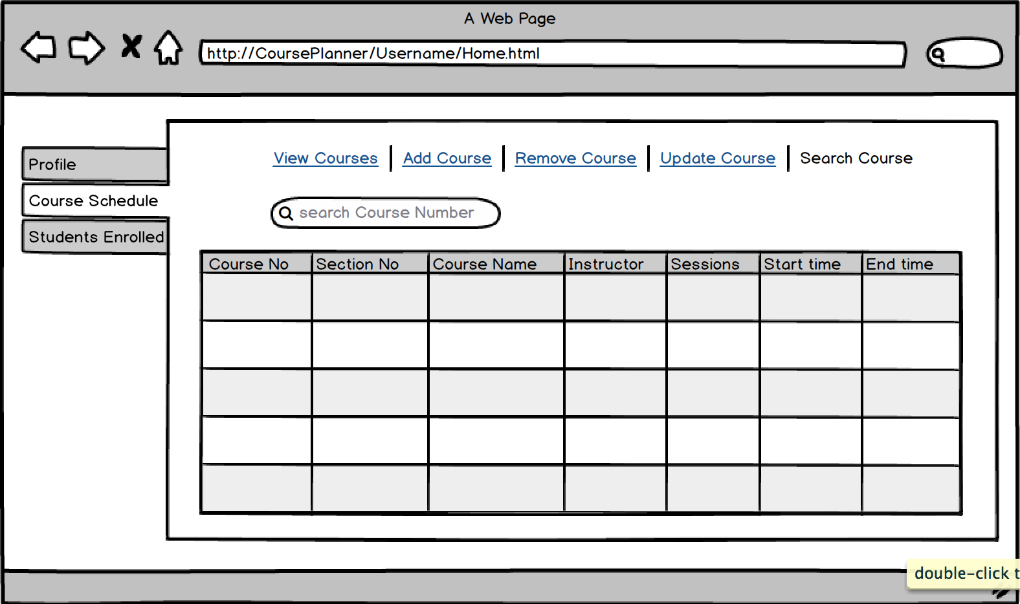

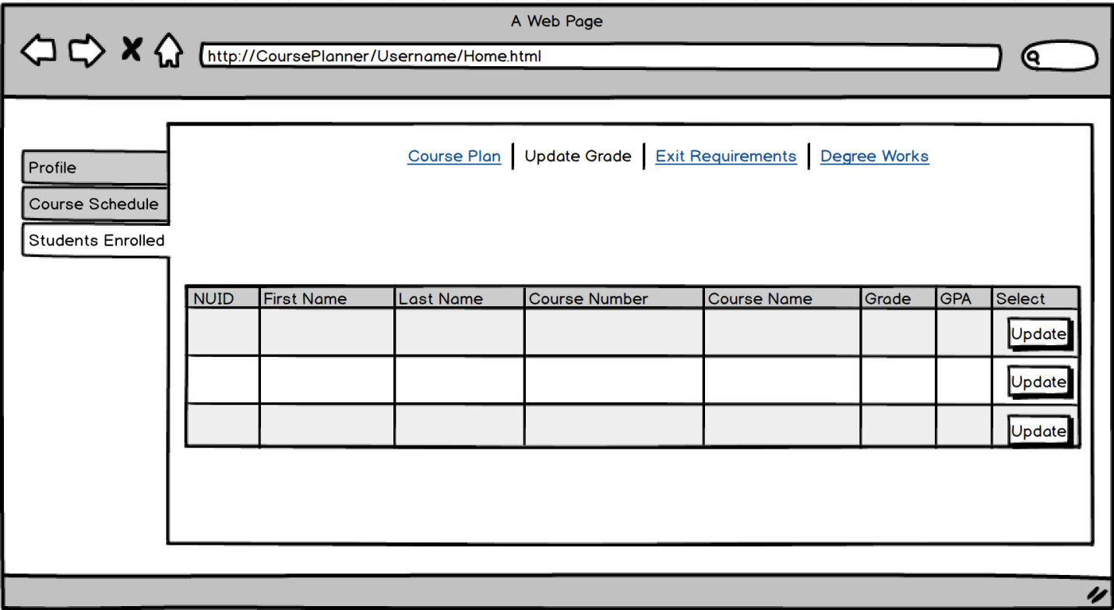

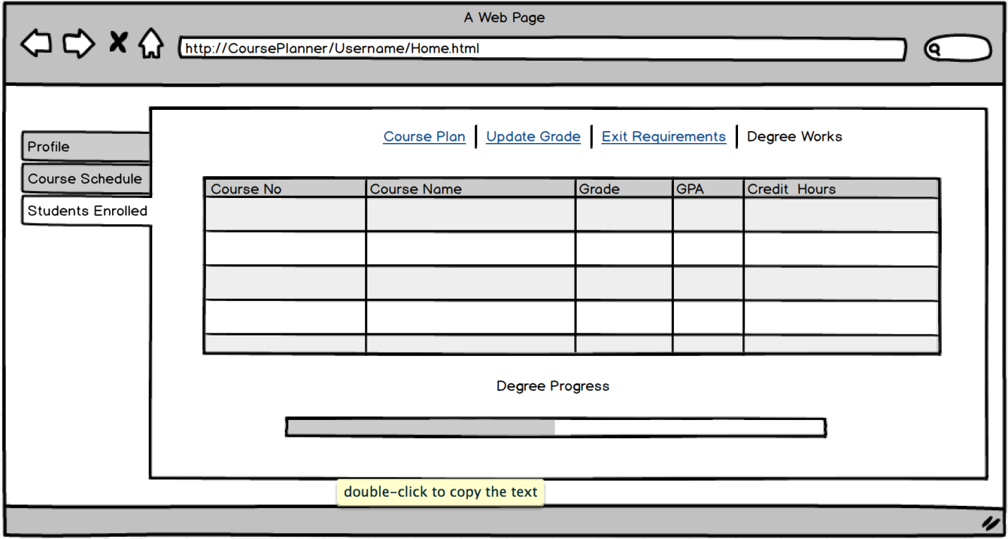

# Screenshots and User Acceptance cases

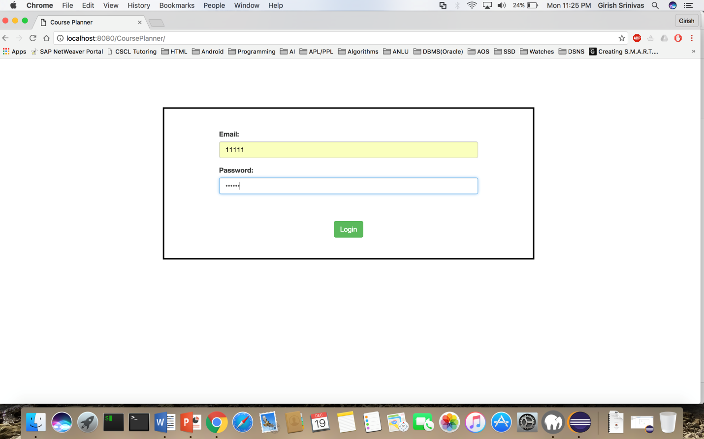

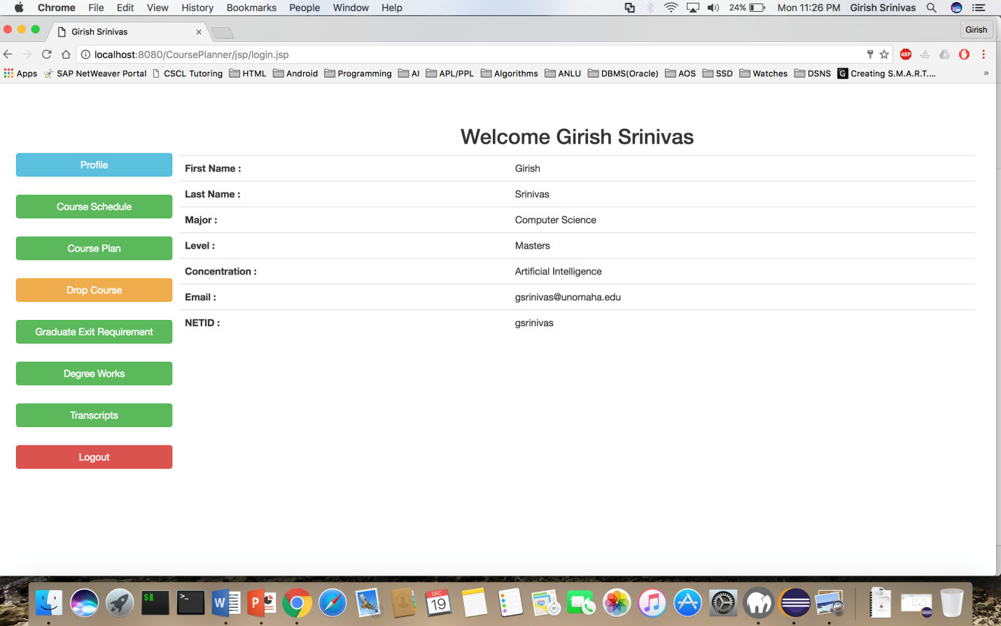

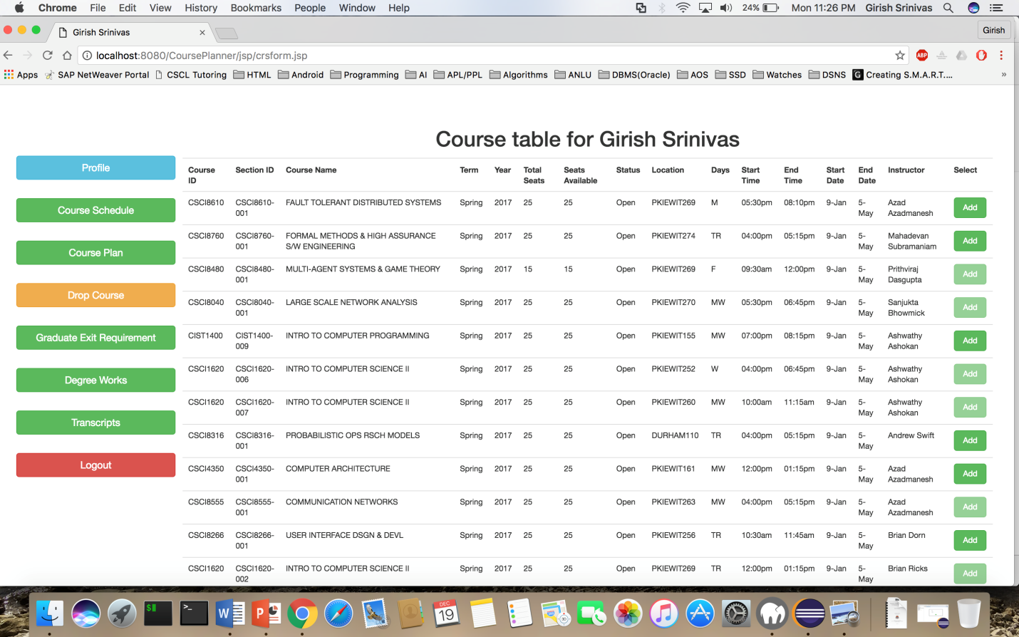

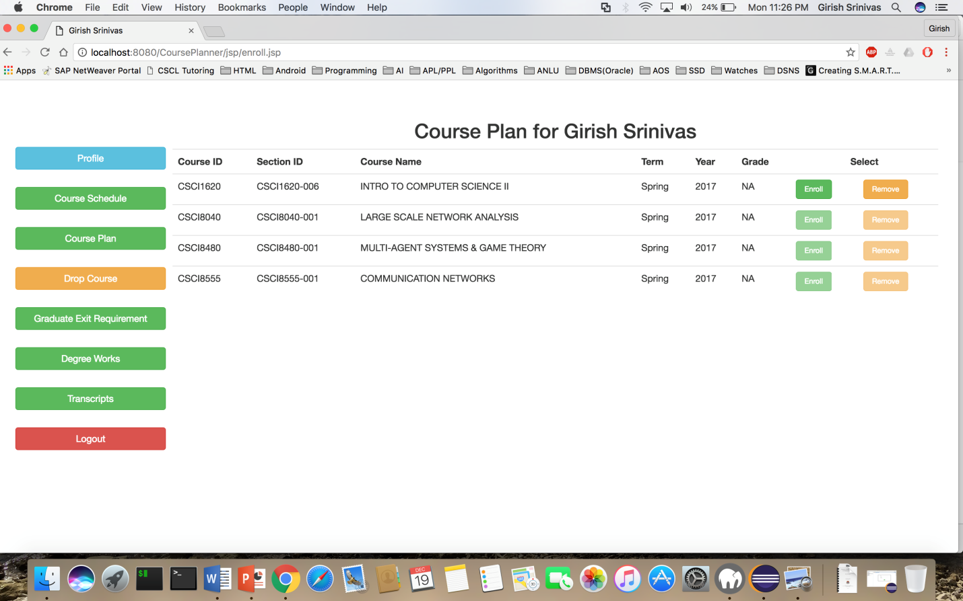

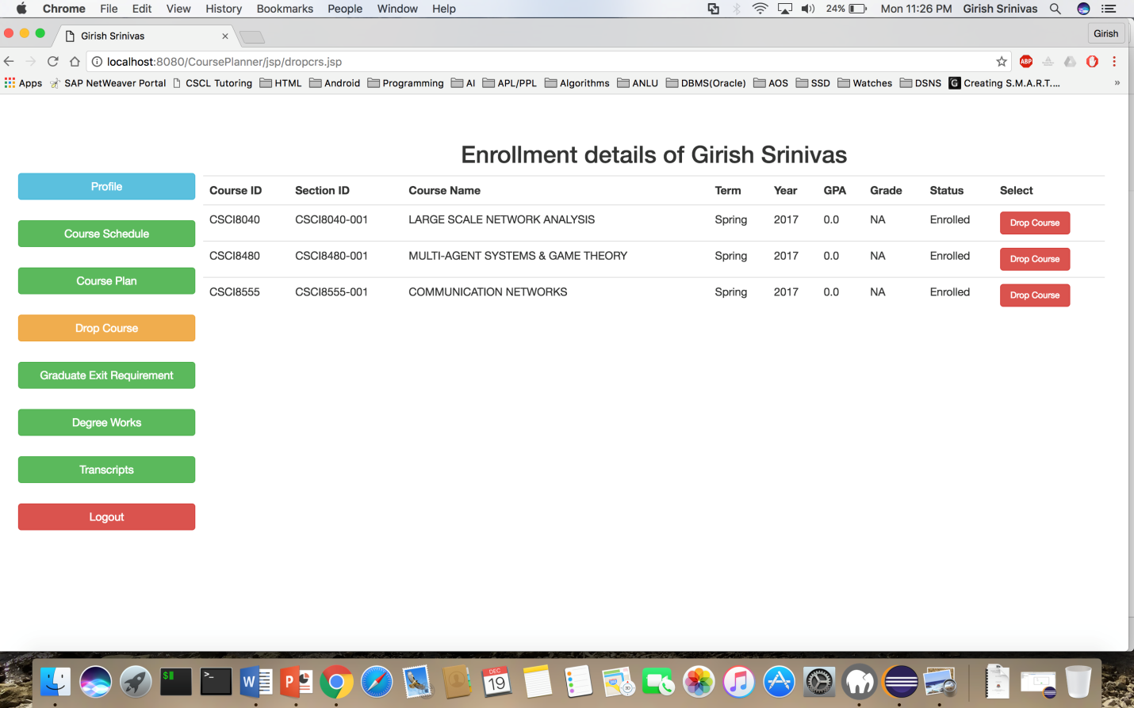

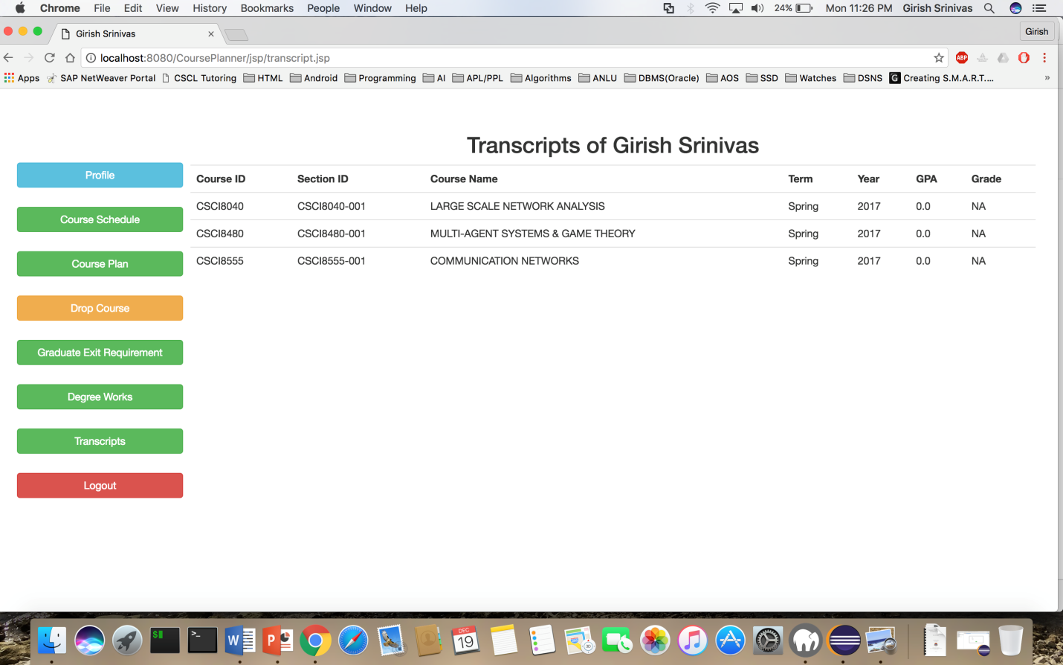

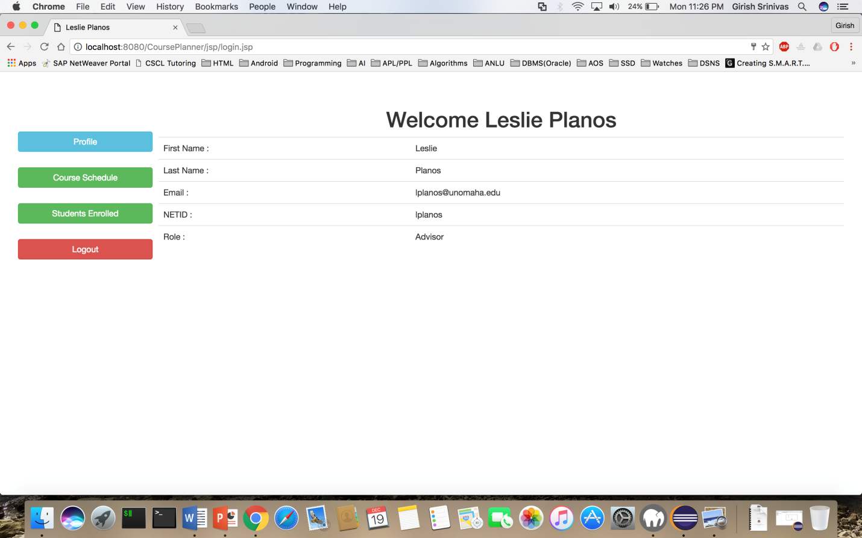

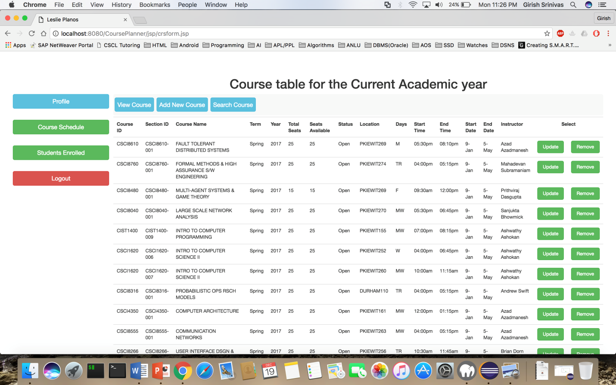

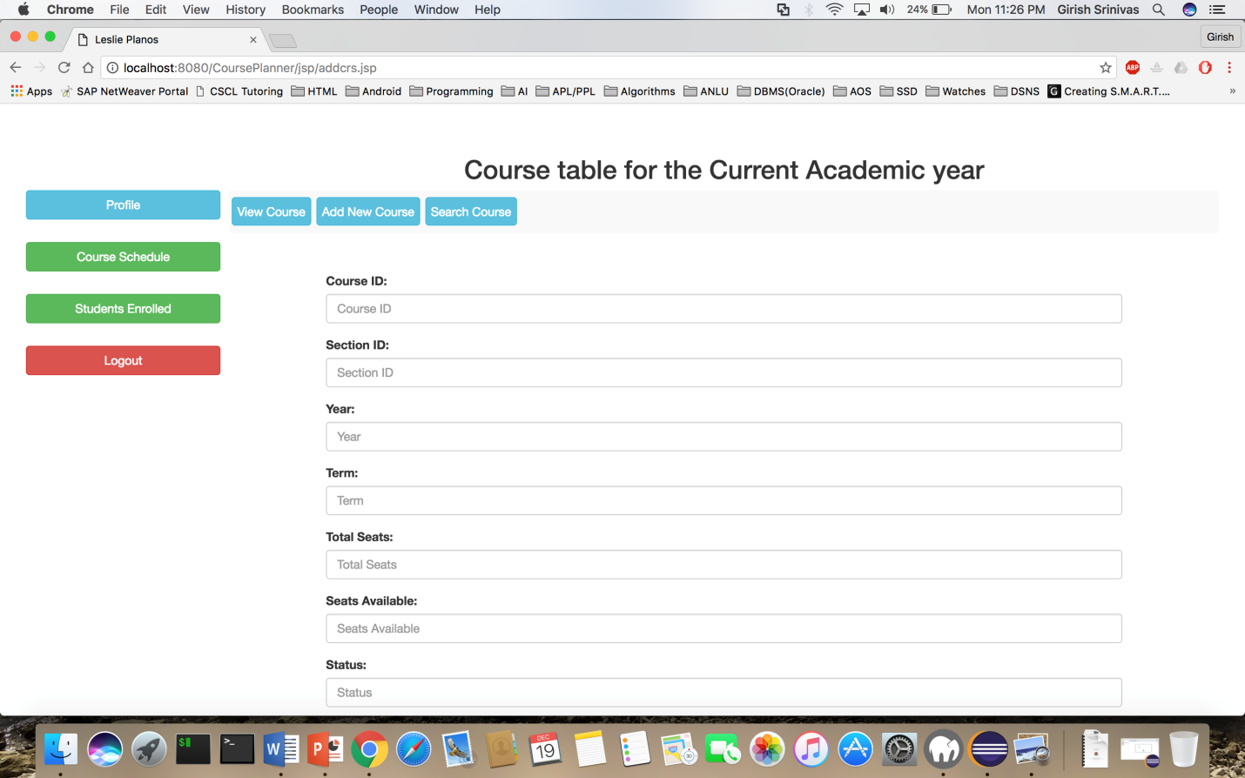

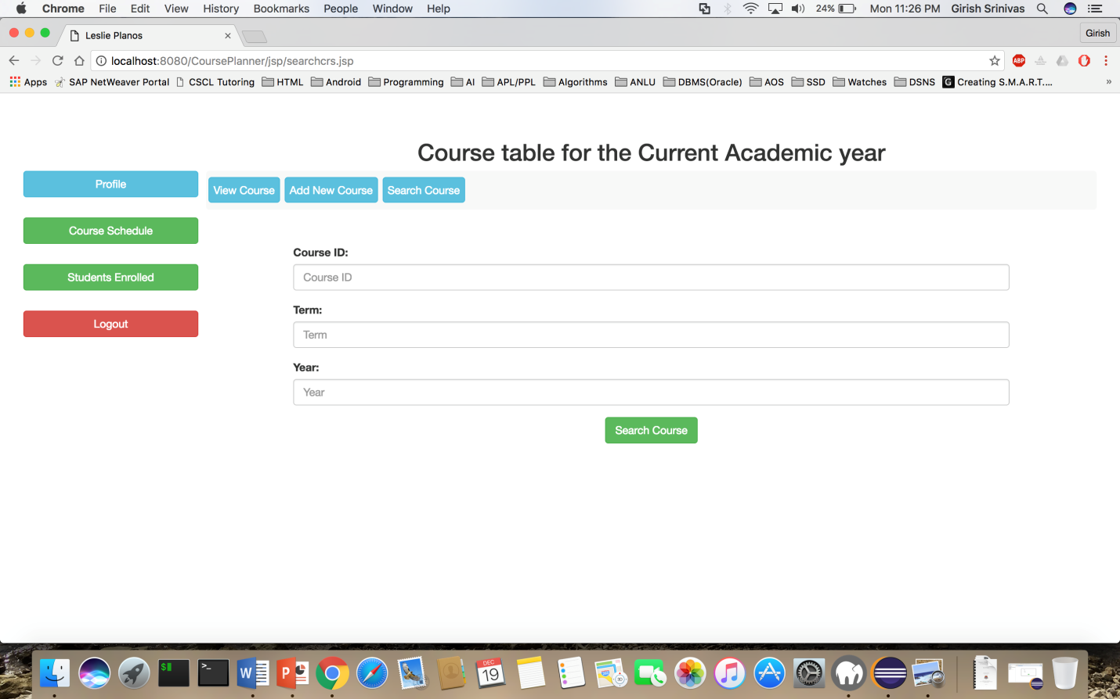

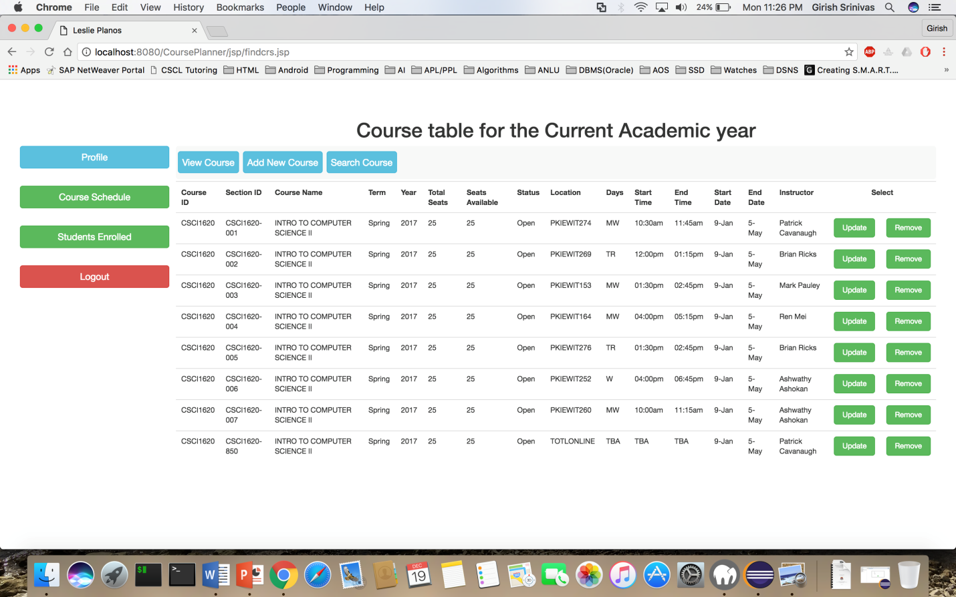

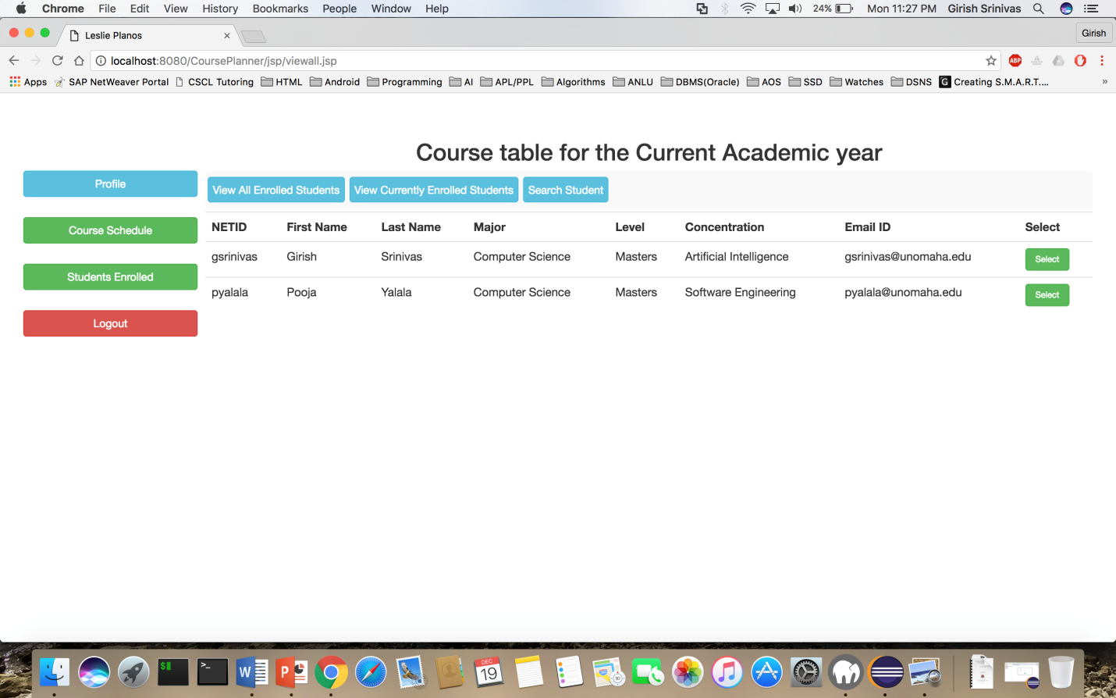

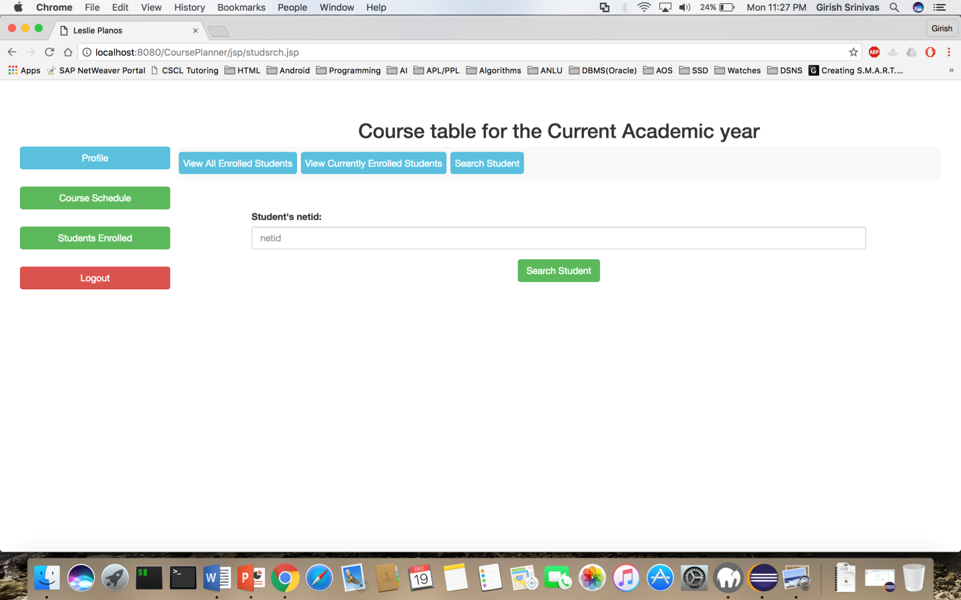

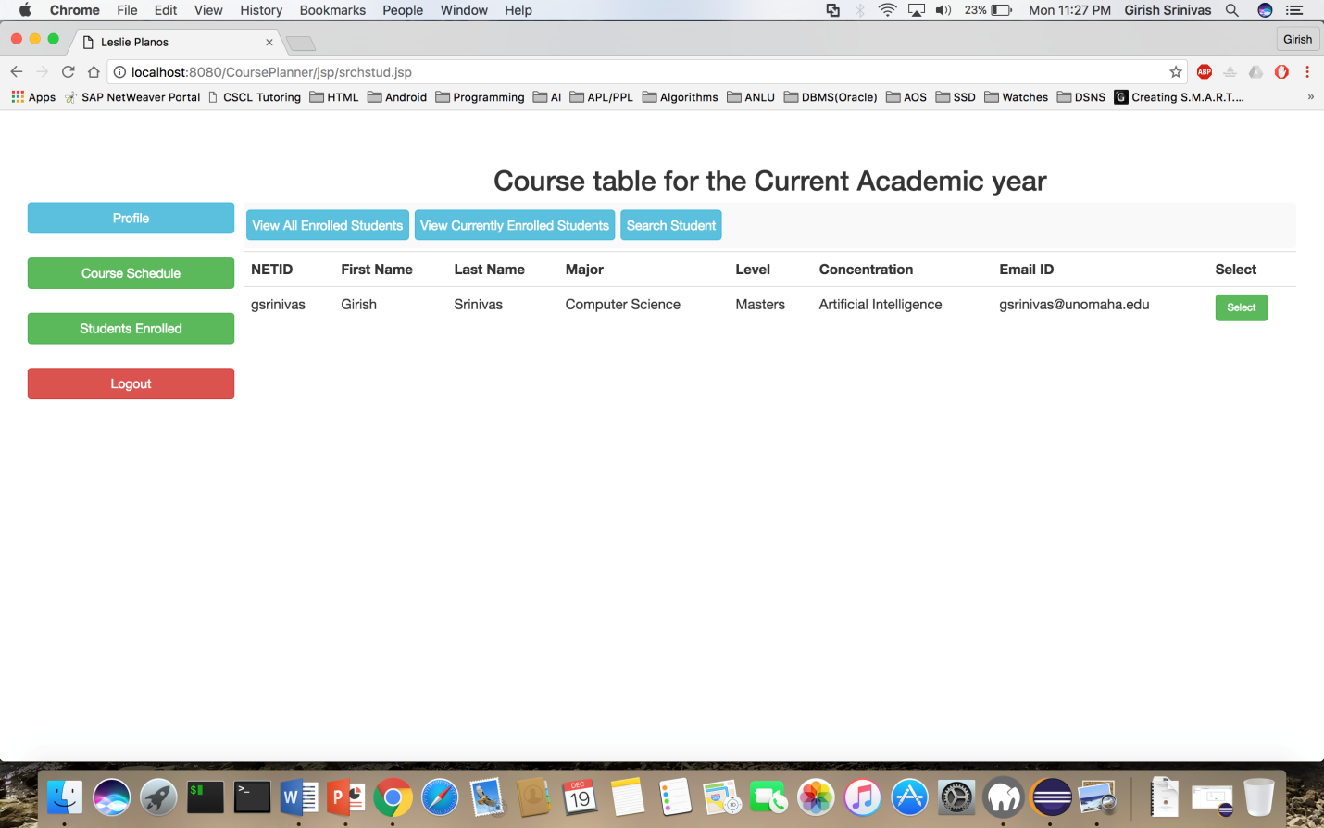

# Summary

A prototype for the proposed system has been developed with the above specified functionalities and tested successfully.

The list of functionalities which are implemented are:

* Creation of tentative course plan
* Adding / removing courses from course plan
* Enrolling / dropping courses.
* Calculate CGPA
* Calculate remaining credit hours based on the exit plan (Capstone or Thesis / Project)
* Generate unofficial transcripts
* Adding / deletion of courses in course schedule
* Searching of courses
* View enrolled students

The list of functionalities that are not implemented are:

* Update of course
* View progress of specific student by the advisor.
* Updating grades in course plan.